n8n Email Automation Deployment Guide (Windows)
This guide provides step-by-step instructions to recreate the "Email Automation" workflow on a completely fresh Windows machine.
This workflow automates:
- Client onboarding
- UAT sign-off tracking
- Automated follow-ups
- Go-Live credential management
using n8n, Gmail, and Google Sheets.

Section 1: Environment Set Up
Phase 1: Google Cloud & Credential Setup (MANDATORY FIRST STEP)
This phase must be completed before opening n8n.
1. Create a Google Cloud Project
- Go to: https://console.cloud.google.com
- Click New Project
- Name: Give your Project a suitable Name
- Click Create
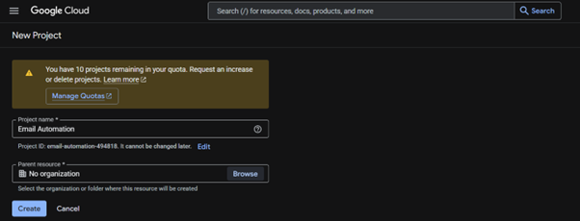
2. Enable Required APIs
After selecting the project that is created, Go to: APIs & Services → Library
Search and Enable:
- Gmail API
- Google Sheets API
- Google Drive API

Selecting the created Project3
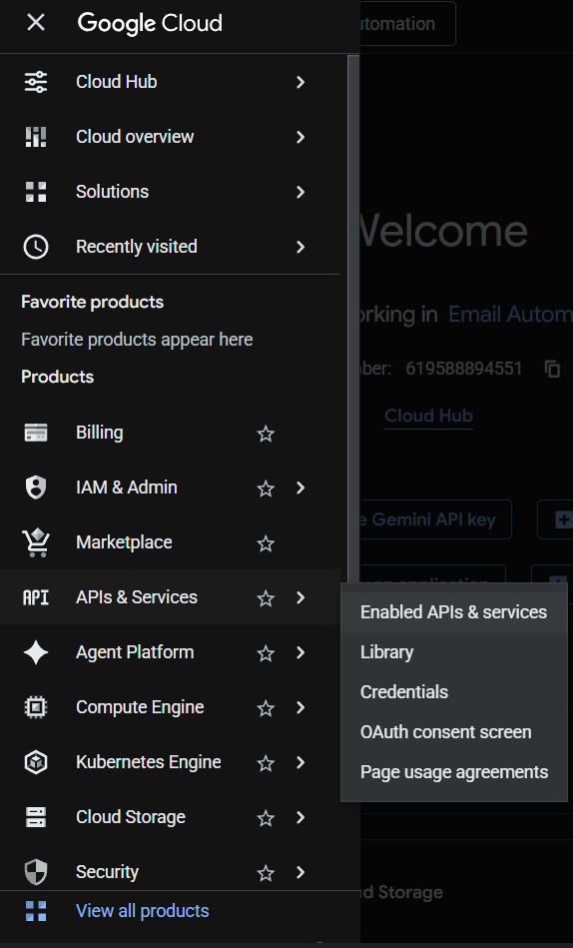
API Services -> Library

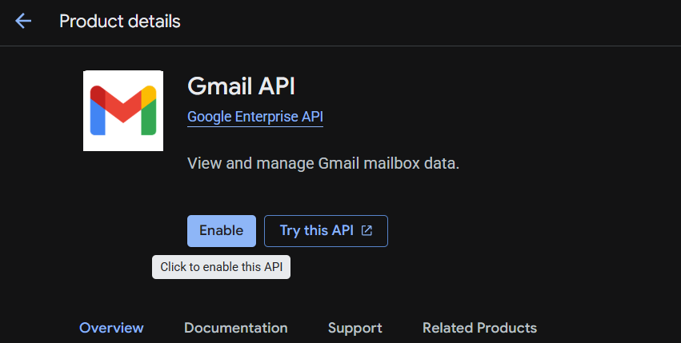
1Enable Gmail API
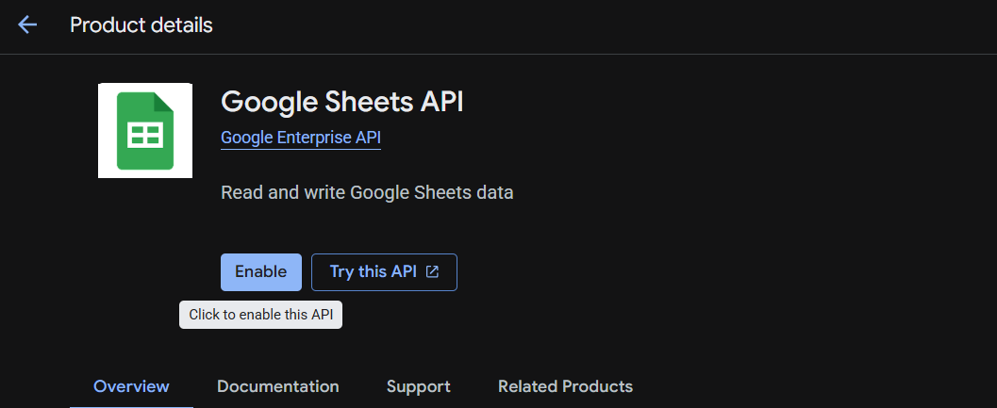
2Google Sheets API Enable
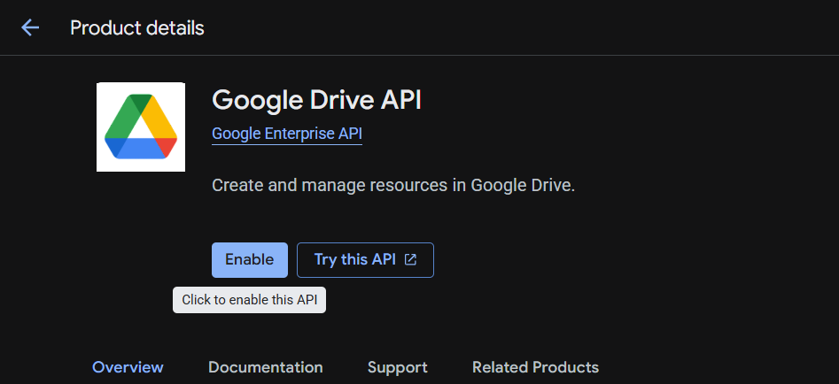
3Google Drive API Enable
3. Configure OAuth Consent Screen
- Go to: → APIs & Services → OAuth Consent Screen
- Fill required details:
  - App Name
  - Support Email [ Account from which you are enabling the Project ]
  - Audience :- External
  - Contact Information :- [ Account from which you are enabling the Project ]
- Add scopes:
- https://mail.google.com/
- https://www.googleapis.com/auth/spreadsheets
- https://www.googleapis.com/auth/drive
4. Create OAuth Credentials
- Go to: APIs & Services → Credentials
- Click: → Create Credentials → OAuth Client ID
- Select: Web Application
- Add Redirect URI: http://localhost:5678/rest/oauth2-credential/callback
- Click Create
- Download JSON as you will no longer be able to see the Client Secret
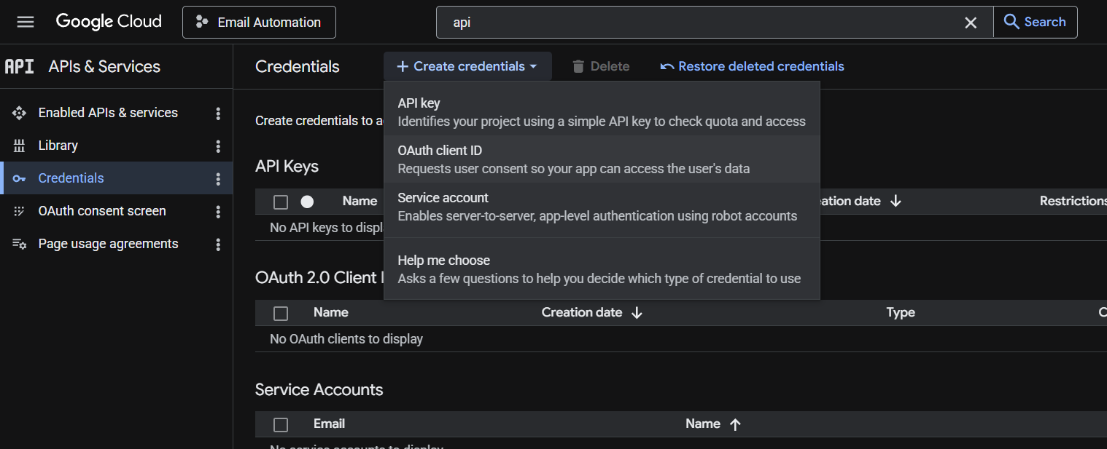
4OAuth Credentials
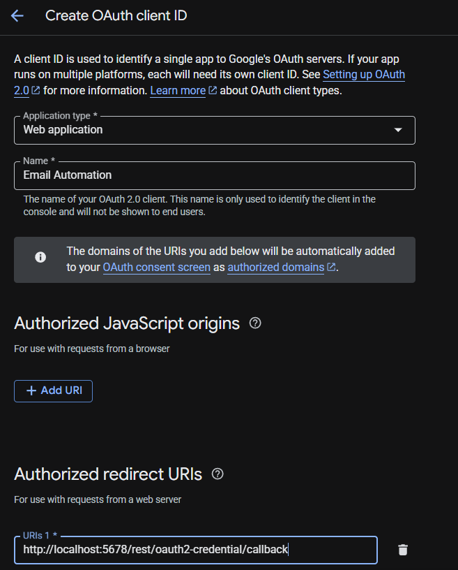
5OAuth ClientID Creation
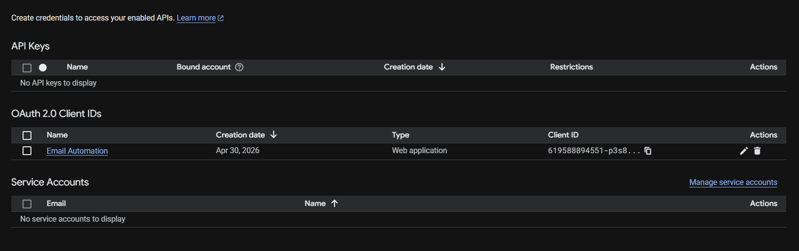
6Successful Creation of Client ID

5. Publish the APP
  - Go to Audience of your project.
  - Select Add Test Users
  - Enter the email of the user you want to add as Tester [ Max Limit: 100]
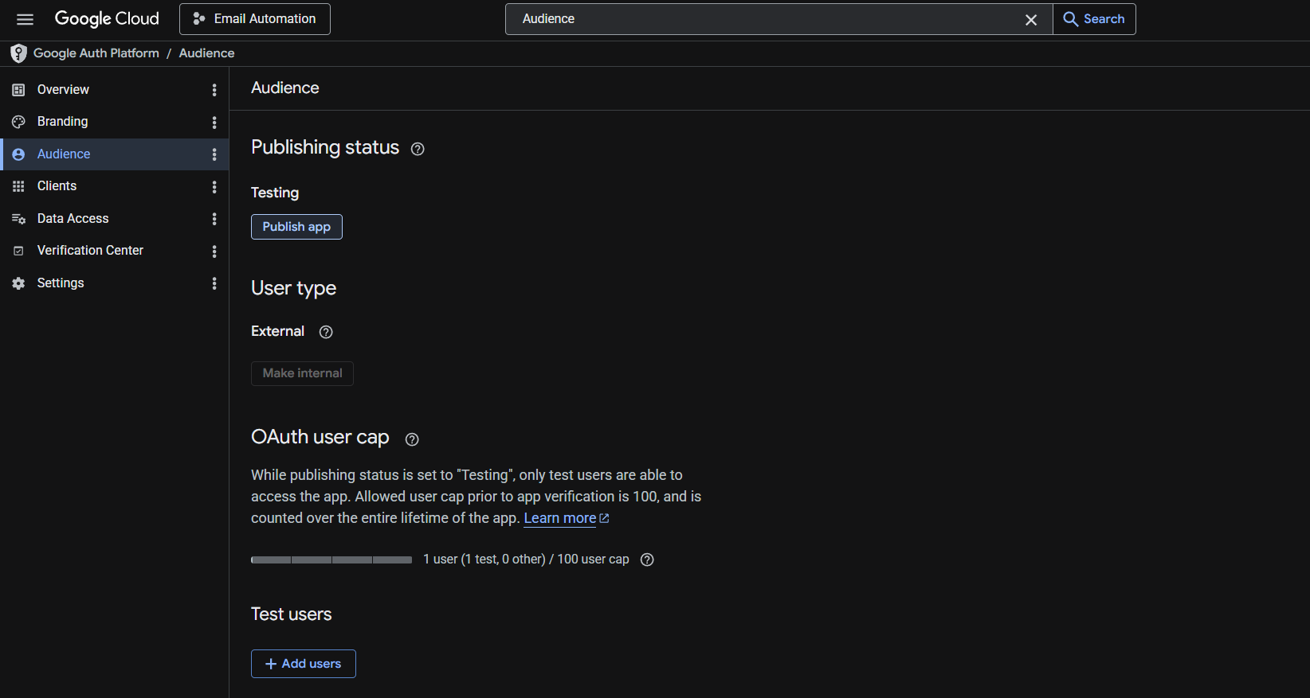
7Test user Page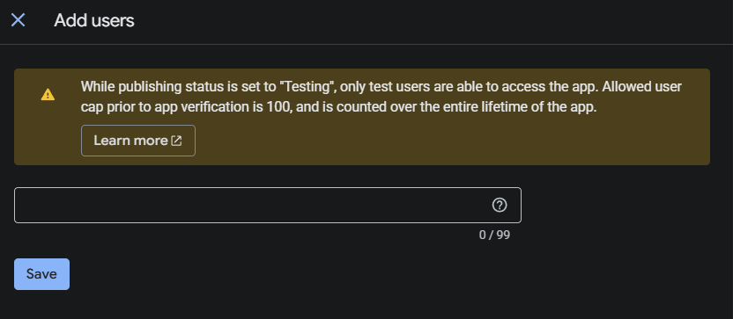
8 Adding new test Users

Phase 2: Install and Run n8n (Windows)
1. Install Node.js
- Download from: https://nodejs.org
- Install LTS version using Windows Installer
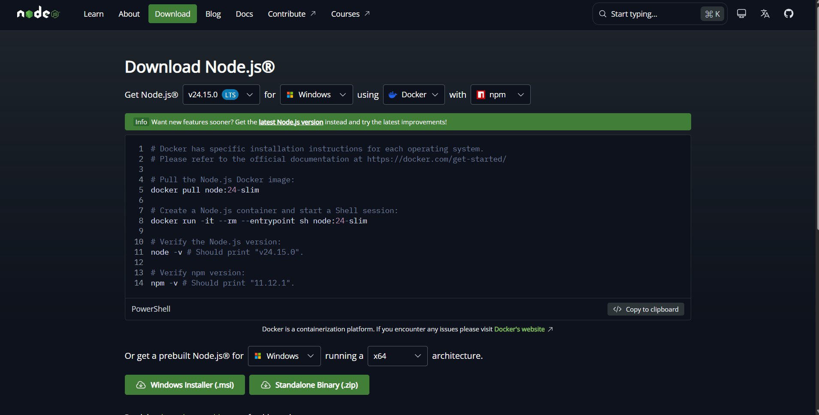
9Node Download Site
2. Install n8n
- Open Command Prompt: npm install -g n8n
- Start n8n: - n8n start
- Open browser: http://localhost:5678

Phase 3: Create n8n Workflow (Project)
1. Create New Workflow
- Click New Workflow
- Name it: [Anything you like]
Phase 4: Create Credentials in n8n
1. Gmail OAuth2 Credential
- Go to: Credentials → New
- Select: Gmail OAuth2
- Enter:
  - Client ID
  - Client Secret
- Click Connect
- Login with Gmail account [Account which has the enabled APIs]
- Click Continue in the Verification of the App.
- Give the project access to all actions with your email. [ Press Select All]
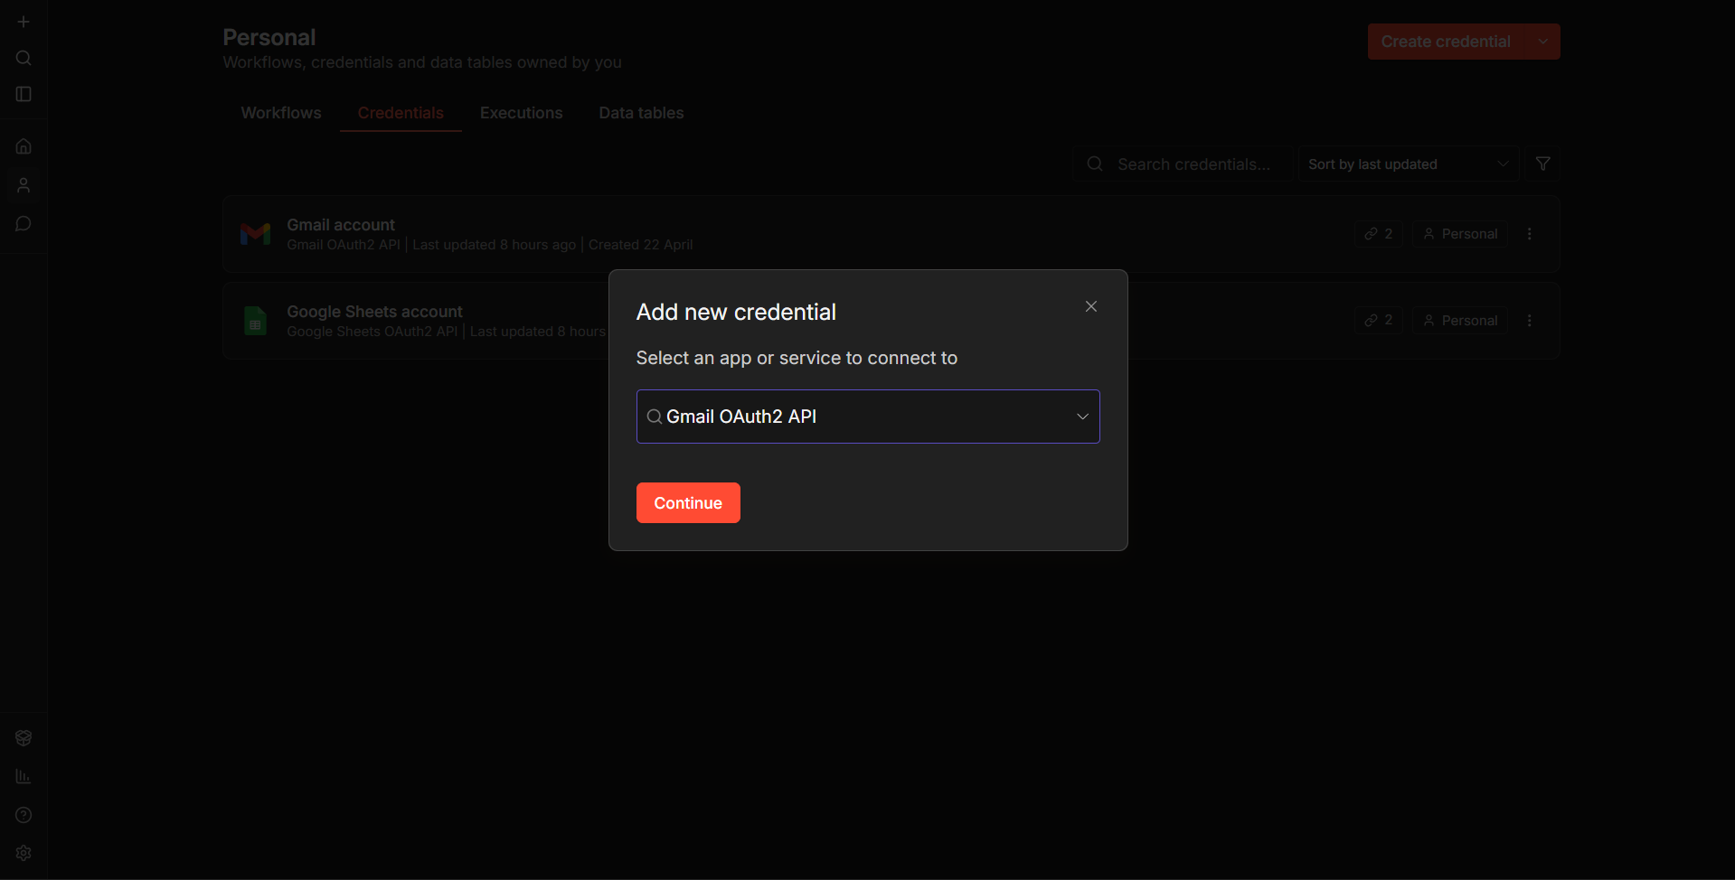
10 Gmail OAuth API Credential Selection
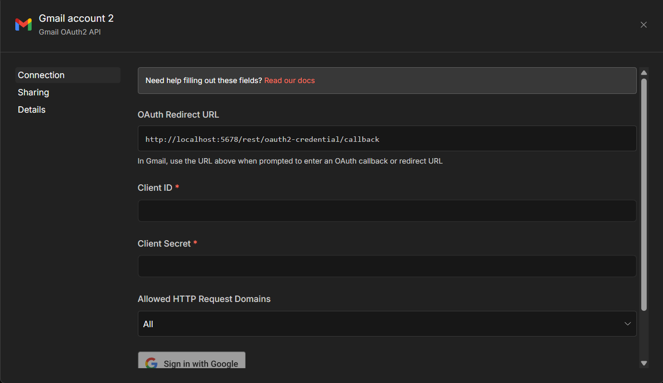
11 Enter Client ID and Secret ID
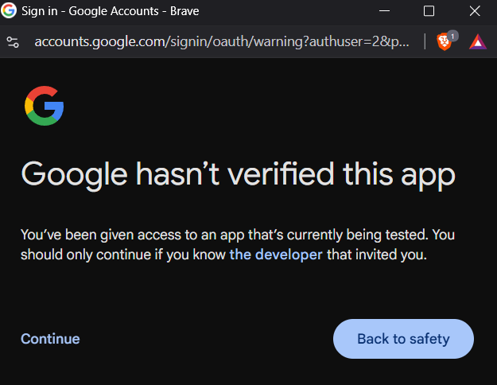
12 Test User Access- Press Continue

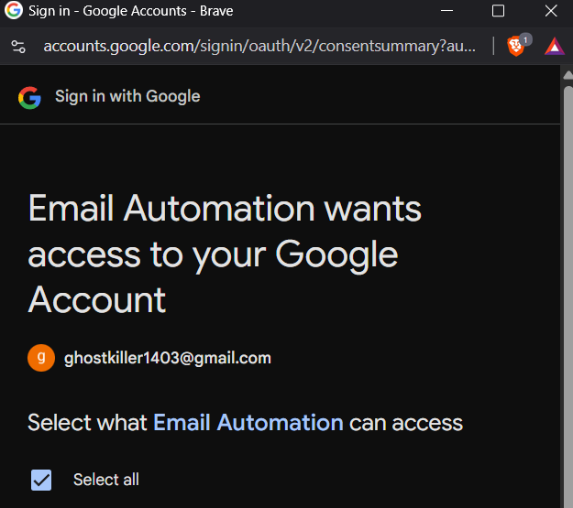
13 Project Permissions for Email
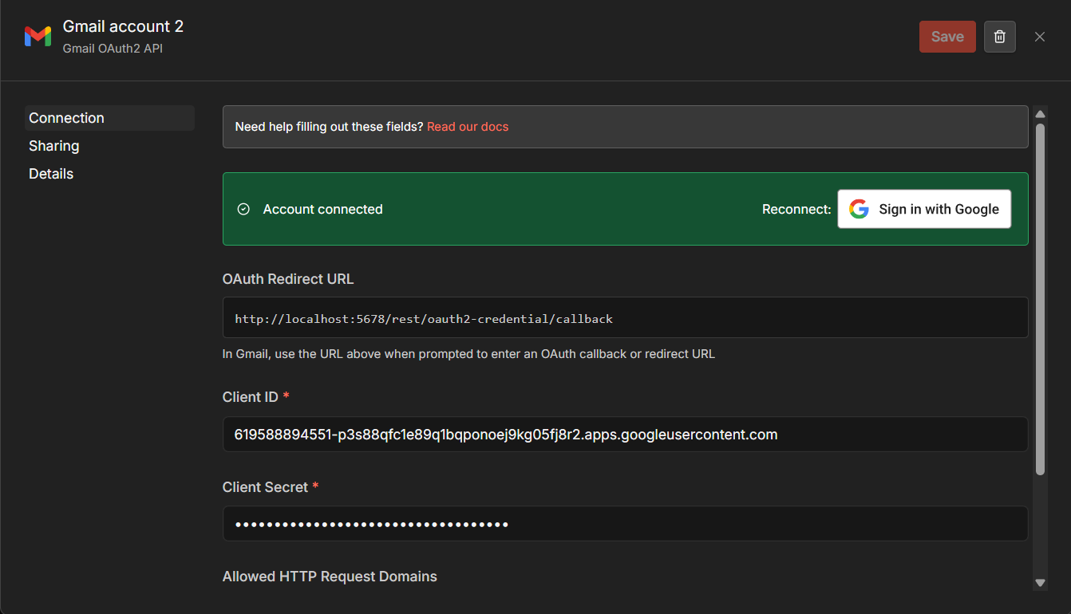
14 Successful Connection of Email Credential

2. Google Sheets OAuth2 Credential
- Create new credential
- Select: → Google Sheets OAuth2
- Enter:
  - Client ID
  - Client Secret
- Click Connect
- Login with Gmail account [Account which has the enabled APIs]
- Click Continue in the Verification of the App.
- Give the project access to all actions with your email. [ Press Select All]
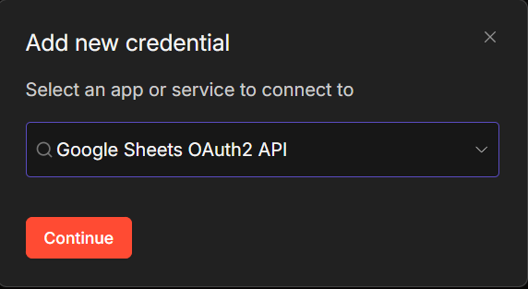
15 Google Sheets OAuth
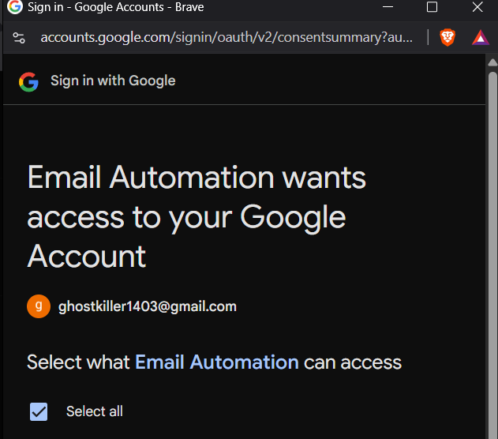
16 Access of Project
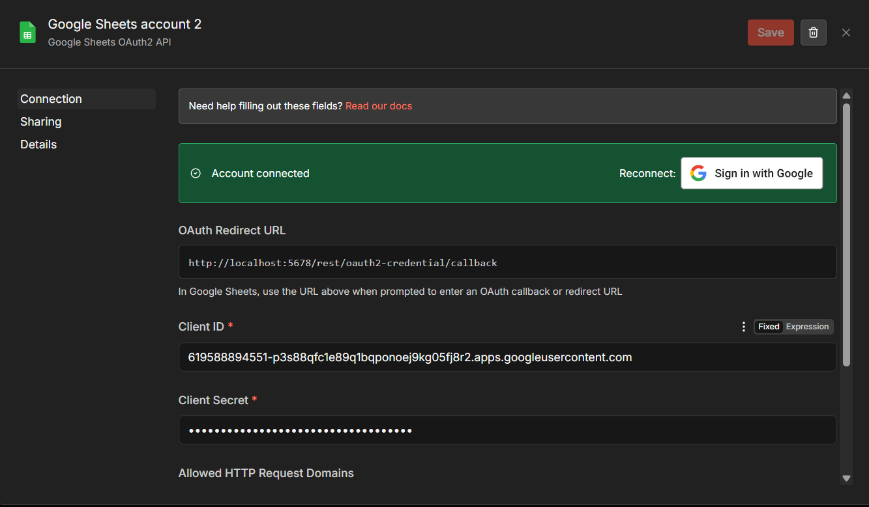
17 Successful Connection of Google Sheet OAuth
Phase 5: Google Sheets Database Setup
1. Create Spreadsheet in the same account which has enabled the APIs.
2. Create Required Tabs
- Sheet 1: Raw_Data
  - Create columns:
    - partner_id
    - ps_code
    - partner_name
    - partner_email
    - product
    - call_date
    - start_date
    - uat_target
    - go_live_target
    - uat_actual
    - go_live_actual
    - thread_ID
    - stage_flag
    - uat_credentials_sent_at
    - last_client_reply_at
    - followup_stage
    - followup_last_sent_at
    - last_processed_message_id
    - last_email_scan_time

IMPORTANT
- Column names cannot be changed
- Order should remain consistent
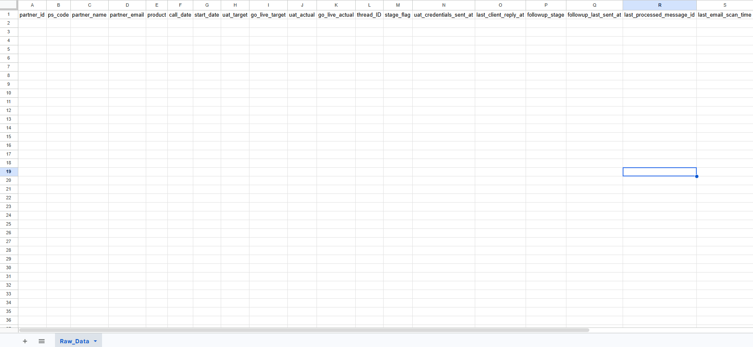
18 Sheet: - Raw_Data
- Sheet 2: Emails
Columns:
    - Person
    - Email
Add entry:
- Person = Onboarding/CC/Client Support/HelpDesk
- Email = Mails for respective Emails
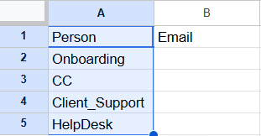
19 Email Sheet

- Sheet 3: Product Details
  - Columns:
- Services
- Essentials for UAT SIGN OFF
  - Add New Products
    - Write Product Name in the Services Column
    - Add all Requirements in one single cell next to the cell
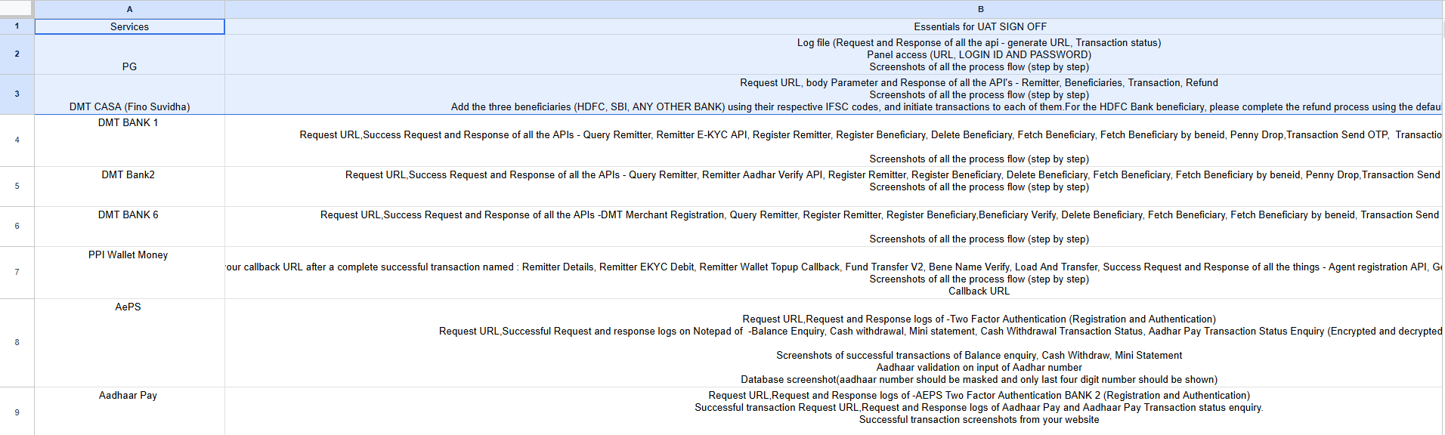
20 Product Details How to be Stored
- Sheet 4 : Partner Details
  - Columns:
    - partner_id
    - ps_code
    - partner_name
    - partner_email
    - state
    - contact_person
    - phone_number
- Formula :- Add this formula:- (=UNIQUE(Raw_Data!A2:D)) in the cell A2.
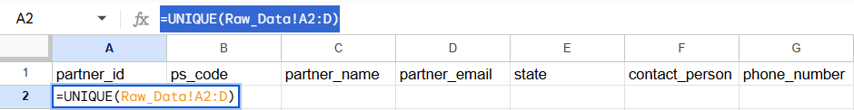
21Partner_Details Sheet

Phase 6: Import and Configure Workflow
1. Import Workflow
- Go to Workflow .
- Create Workflow.
- Click the hamburger menu on the top right near the Publish button.
- Click import from file.
- Select Email Automation. Json and click Open.
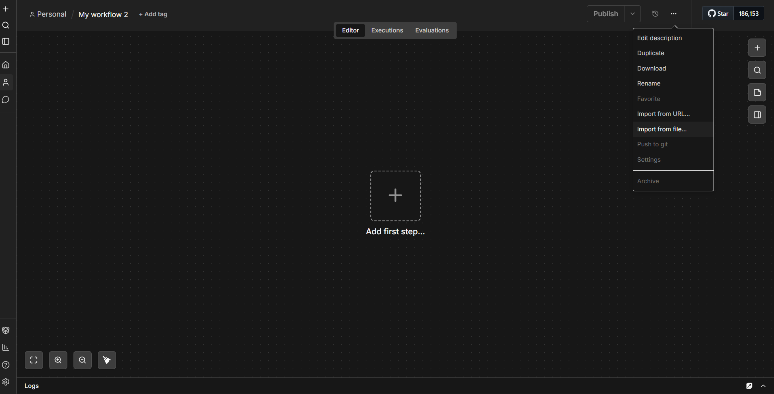
22Import from File function from Menu
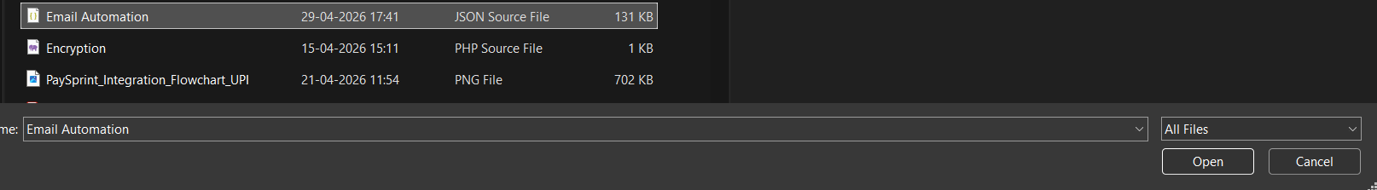
23 Selecting Email Automation JSON File
2. Re-map Credentials
Each node will show errors like:
- Missing Gmail credential
- Missing Sheets credential
Steps
- Double Click on Every Sheets and Gmail Node to access the settings.
- Change only the credential to the created credential.
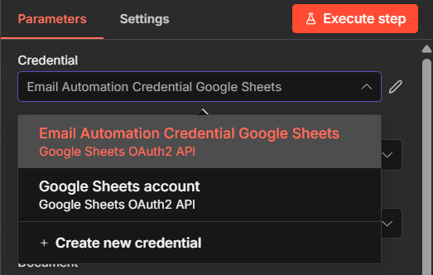
24 Credentials for Google Sheets
- Google Sheet node Settings
  - For each of the Google Sheet node, as you change the credentials, the settings will also change.
  - From the document bar, use the dropdown menu to select the created google sheet document.
  - Check the name of the node on the top left along with the Screenshot in order to configure the node along with the sheet of the document.
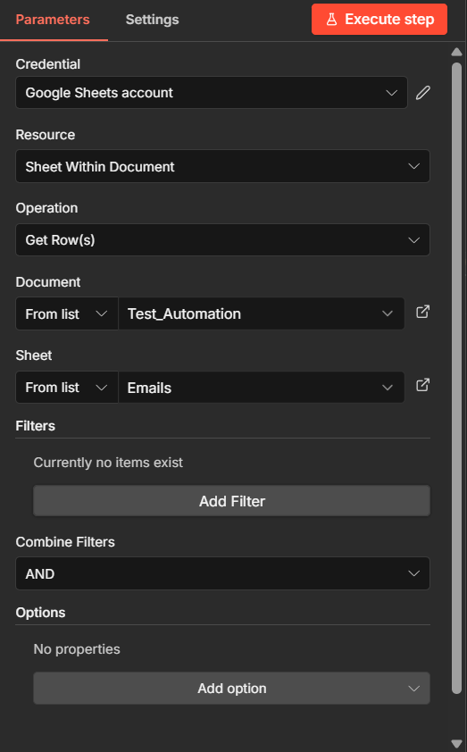
25 Get Client Onboarding Mail
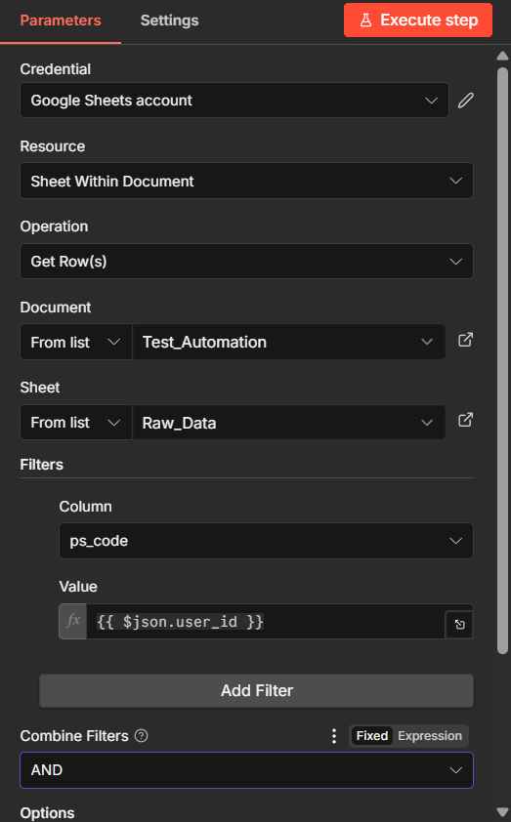
26 Node :- Get Live Products

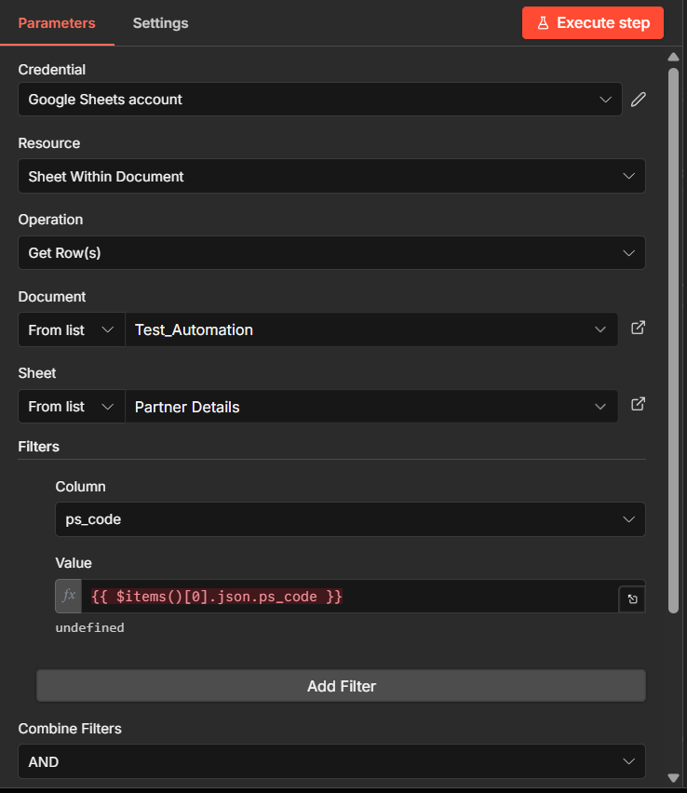
27 Node:- Get Partner Details

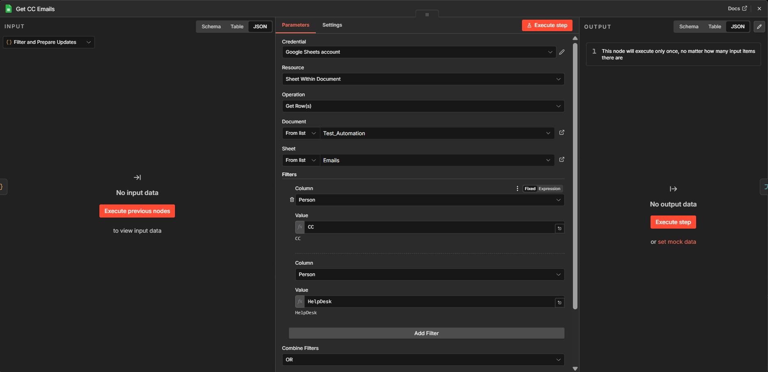
28 Node :- Get CC Emails
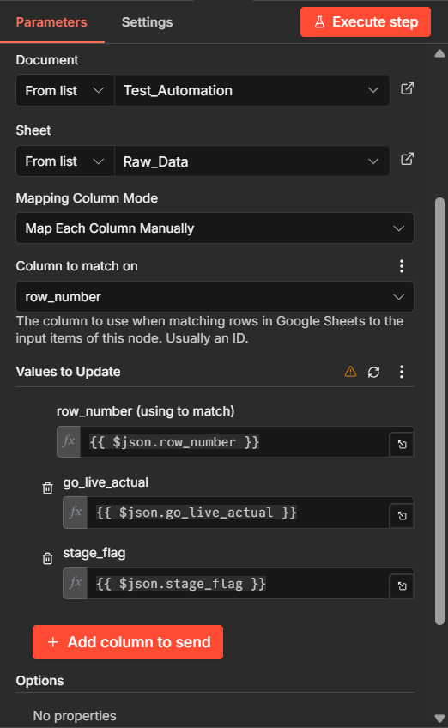
29 Node :- Update Live Status
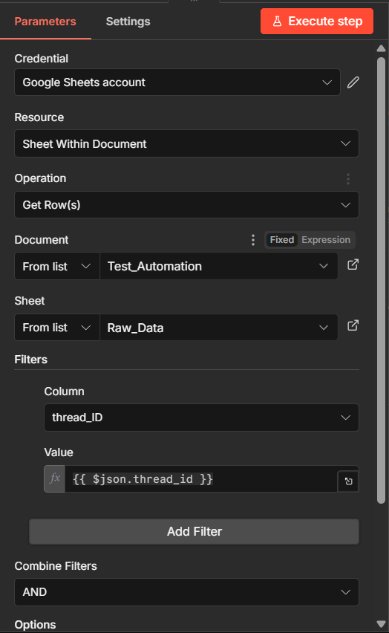
30 Node:- Check ThreadID
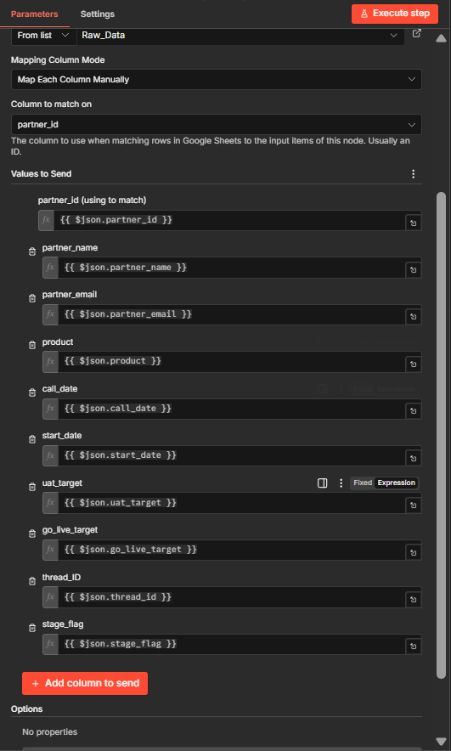
31 Node:- Partner Append
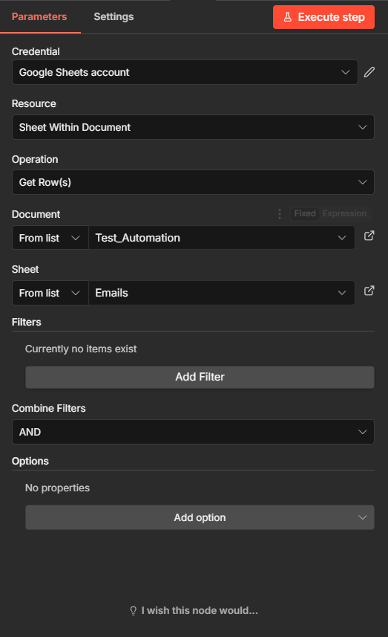
32 Get Emails for CC Node
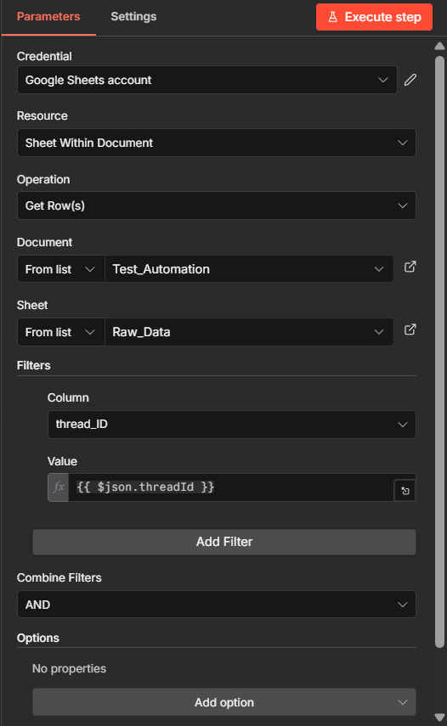
33Get partner Email for CC Node

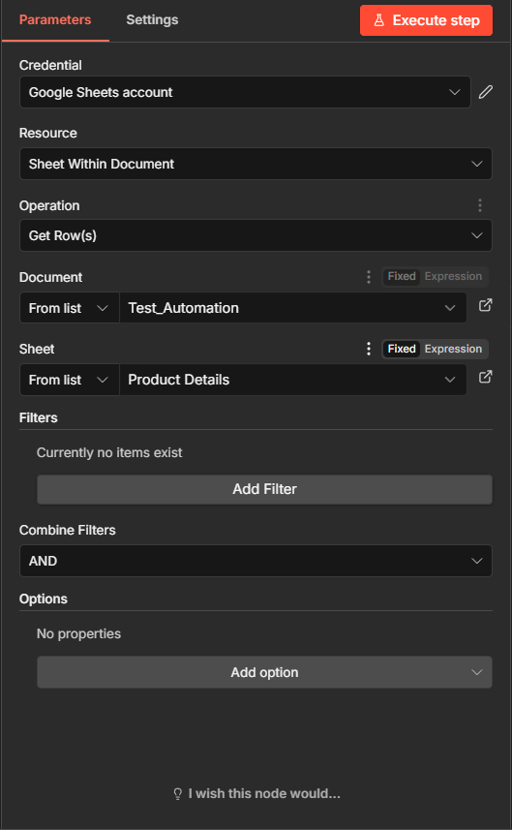
34Get Product Details for Sign Off

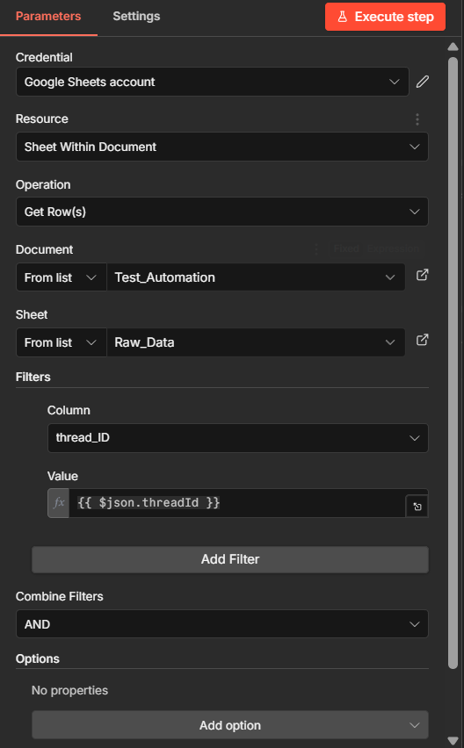
35 Node :- Requirement Stage Flag Set

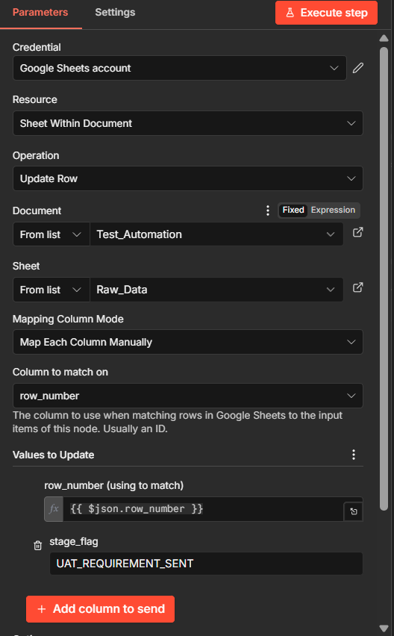
36 Node:- Requirement Flat Updated

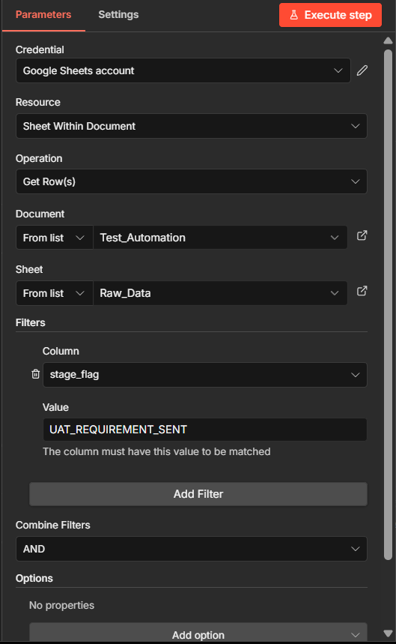
37 Node:- UAT Status Checker

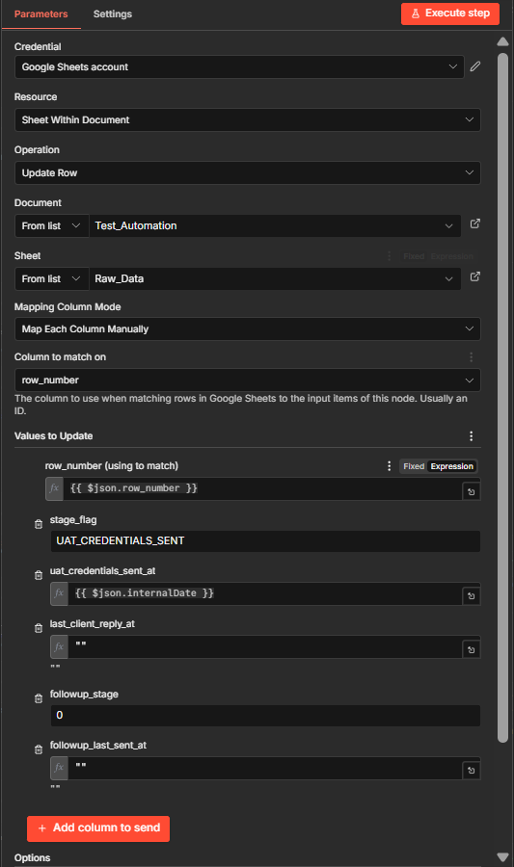
38 Node: Credential Flag Set
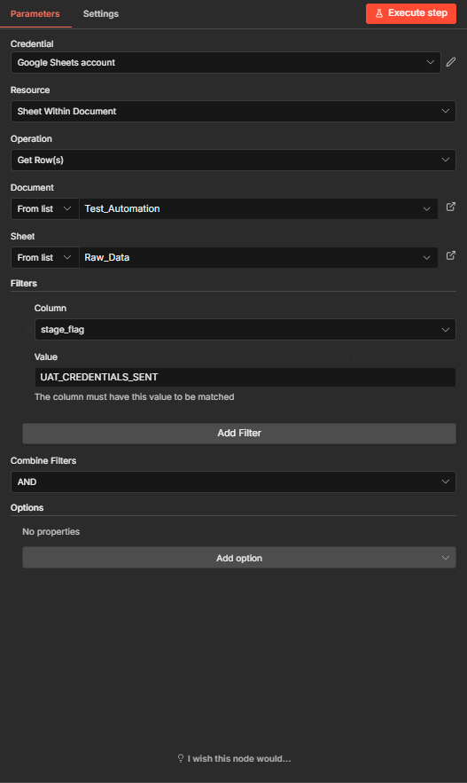
39 Node :- Get Emails whose Credentials Are Sent
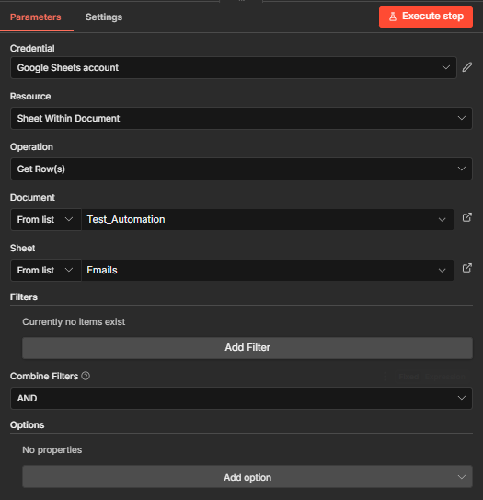
40 Node:- Get Support Emails

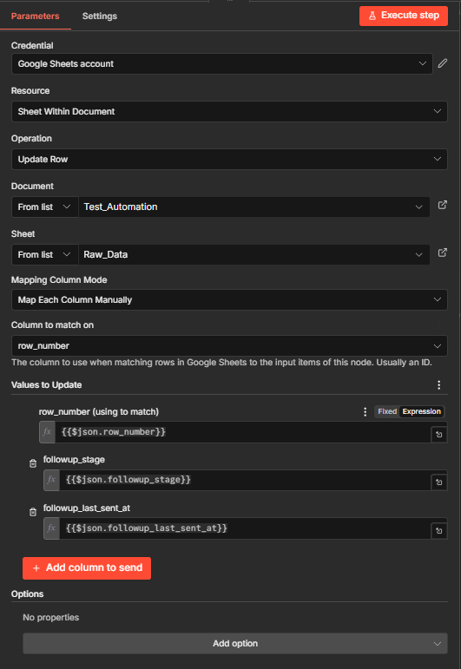
41 Node:- Follow Up Updater
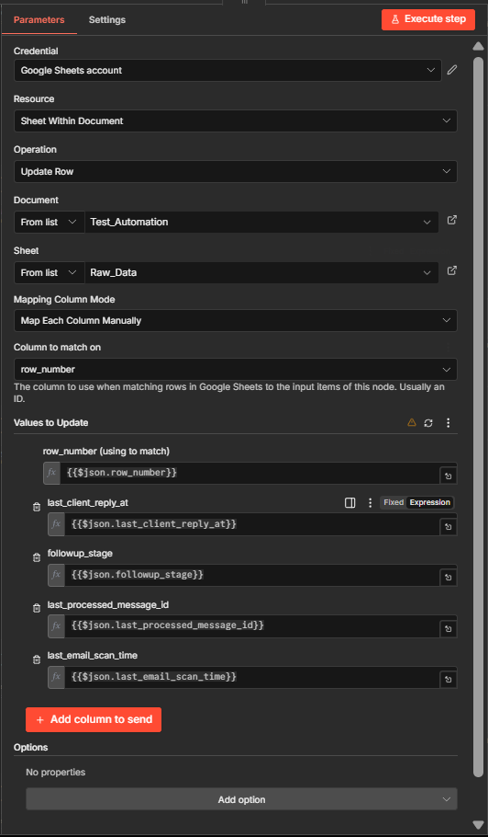
42 Node:- Client Reply Updater
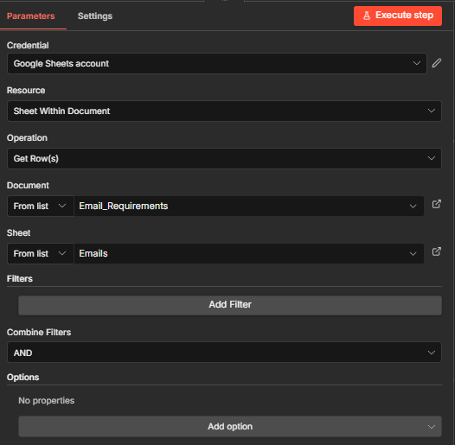
43 Node:-Get Emails List for Internal Senders
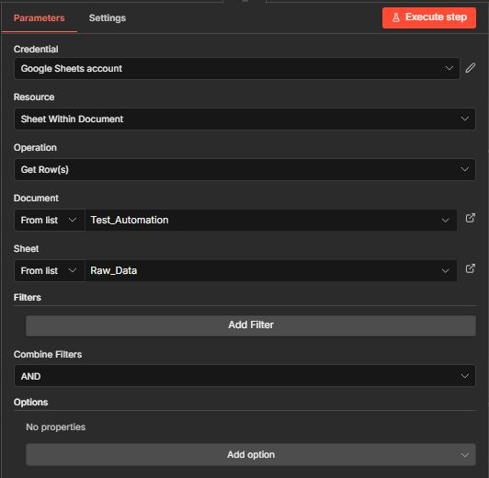
44Node:- Get Data of Partners
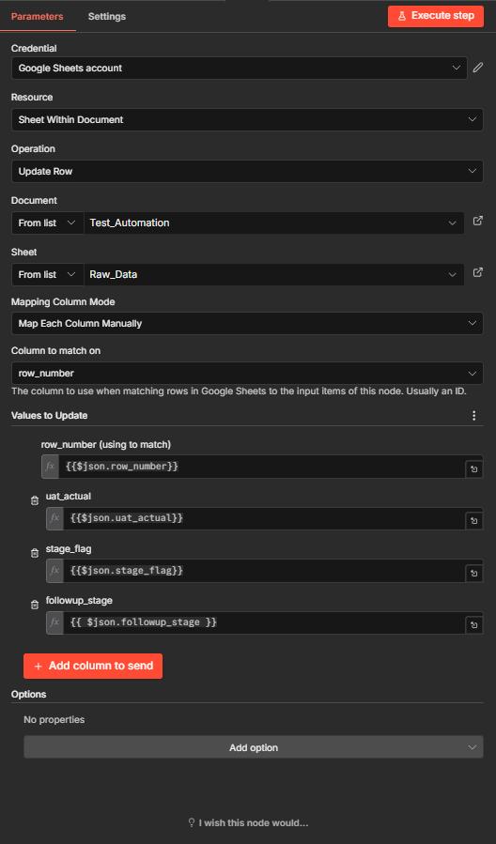
45 Node:- Update Row for UAT/Go-Live
- Gmail Node Settings
  - Same as the Google Sheet nodes, you will need to add the credentials.
  - The setting up the credentials is the same way as the Google Sheet Nodes.
  - Select the Gmail OAuth Credential and simply click and save it.
  - No need to change anything.
Important Notes:-
Variables that Can be Changed
- Workflow name
- Credential names
- Sheet file name
- Email text (except variables)
Cannot Be Changed
1. Column Names in the Google Sheet (CRITICAL)
2. Node Names Used in n8n
3. Email Variables
Example: ${Partner_Name}
4. Thread ID Logic
Used as:
- Primary key
- Email tracking

SECTION 2: Workflows

STEP 1: IDENTIFY NEW ONBOARDING EMAIL
Client Support Team must:
- Open Gmail
- Look for email from Onboarding Team
- Verify:
  - Subject contains: Onboarding Initiated – Partner Integration Plan
  - Do not Open it
46 New Partner Email from Client Onboard Team
STEP 2: EXECUTE WORKFLOW
Workflow:- 1. New Email Checker 5. Live Credential Checker
On Successful Completion,
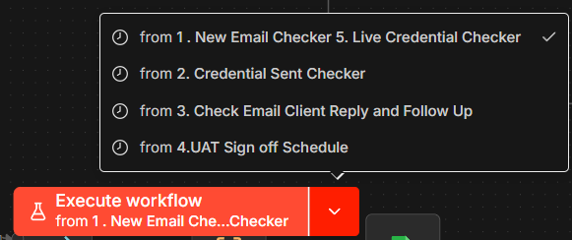
47 Execute New Email Checker Workflow
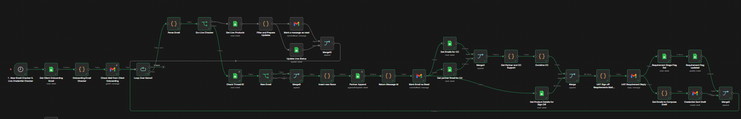
48 Successful Completion

STEP 3: VERIFY GOOGLE SHEET ENTRY
- Open Raw_Data sheet
- Validate:
- All products inserted (1 row per product)
- Correct values:
  - partner_name
  - partner_email
  - product
  - thread_ID
- CRITICAL CHECK:
  - stage_flag = UAT_REQUIREMENT_SENT
STEP 4: VERIFY UAT REQUIREMENT EMAIL
Go back to Gmail:
- Open same thread
- You will see:
→ Draft email generated automatically
STEP 5: COMPLETE & SEND UAT MAIL
Action Required:
- Enter:
  - Username
  - Password
- Add:
  - To (partner)
  - CC (support emails)
Then:
- Click Send
49 Draft Made After Successful Run

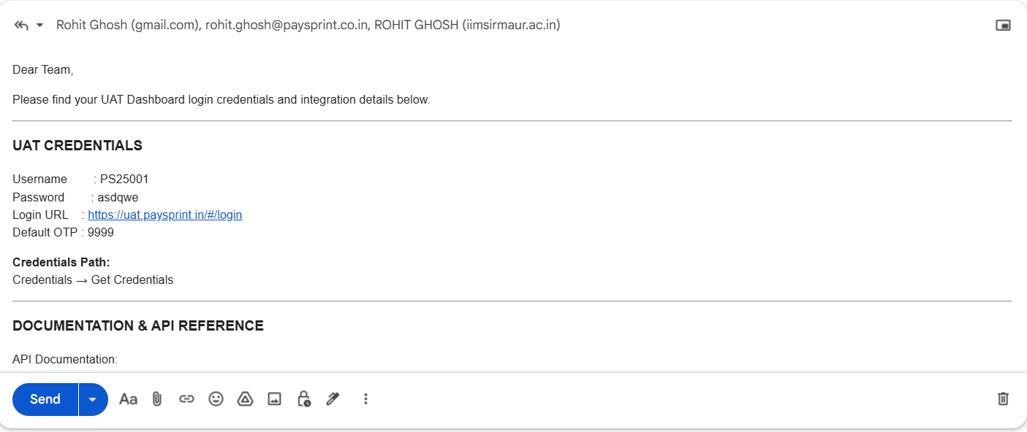
50 Draft with UAT Details to be Sent
STEP 6: UPDATE CREDENTIAL STATUS
▶️ Run: Workflow → 2. Credential Sent Checker
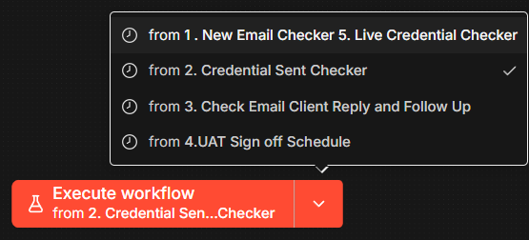
51 Second Workflow
STEP 7: VERIFY SHEET UPDATE
- Check Raw_Data
- Must update: stage_flag = UAT_CREDENTIALS_SENT

52 Successful Completion of Second Workflow

SECTION 3: FOLLOW-UP SYSTEM
STEP 8: CHECK CLIENT RESPONSE STATUS
For ALL active partners:
▶️ Run Workflow → 3. Check Email Client Reply and Follow Up
🟡 CASE 1: NO CLIENT REPLY
System will auto-update:
Days | followup_stage
3 | 1
5 | 2
7+ | 3
Sheet Columns Updated:
- followup_stage
- followup_last_sent_at
🟡 CASE 2: CLIENT REPLIED
✅ Expected Sheet Updates:
Column | Expected
last_client_reply_at | Updated [Current System Date]
followup_stage | 0
followup_last_sent_at | Reset
last_processed_message_id | Updated [Current System Date]
last_email_scan_time | Updated [Current System Date]

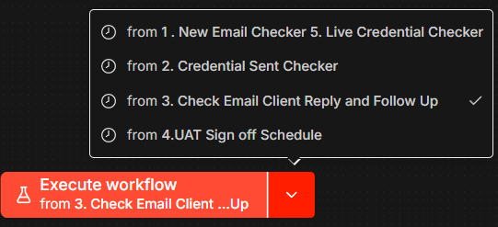
53 Third Workflow to be sent

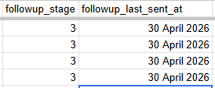
54Successful Follow up Stage 3 at 30 April 2026
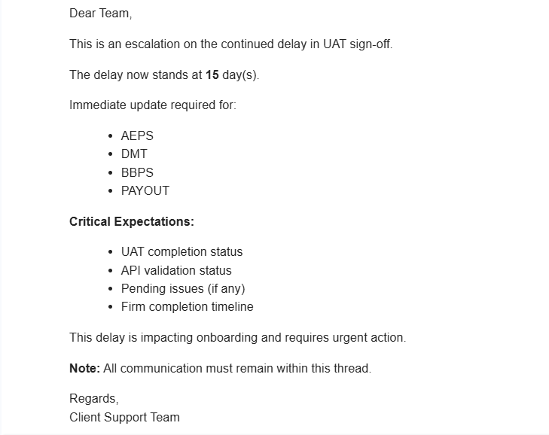
55 Follow up Email Stage 3 at 15 days late
SECTION 4: UAT SIGN-OFF FLOW
STEP 9: SEND UAT SIGN-OFF EMAIL
Client Support sends structured email:
- Product-wise completion
- Sign-off dates
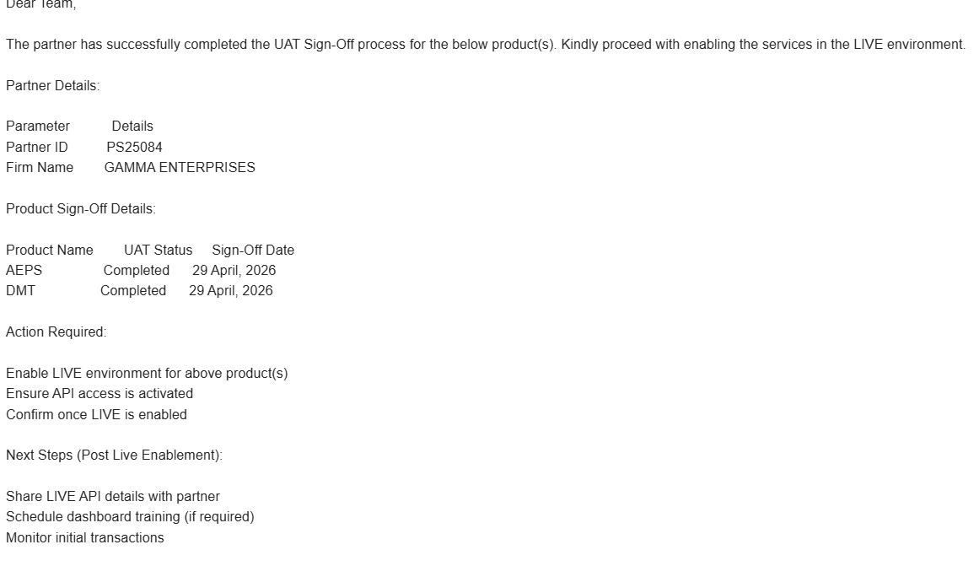
56 UAT Sign Off Mail
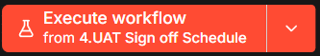
57 Workflow

STEP 10: Update Partner ID (PSCODE)
Mandatory:
- Add ps_code in:
  - Partner ID field
  - Google Sheet
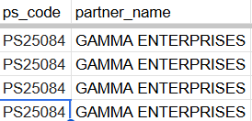
58 PSCODE
STEP 11: Execute Workflow
- UAT Sign off Schedule
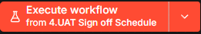
59 Workflow

Step 12: Validate Sheet
- stage_flag = UAT_SIGNOFF_DONE

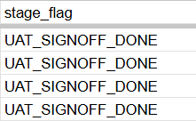
60 Successful Sign Off Done
- Add Phone Number, Contact Person and State in Partner_Details Sheet.

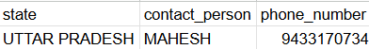
61Example of Adding Partner_Details
7. GO-LIVE PROCESS
STEP 13: Receive Live Credentials Email
Email must include:
- User ID
- Enabled services
- Login URL
- DO NOT Read it
62 Live Credential Email
STEP 14: Execute Workflow
Run :- 1. New Email Checker 5. Live Credential Checker
63 Workflow to be Run
STEP 15: Validate Sheet Update
- Check stage_flag = GO_LIVE_DONE
- Also verify go_live_actual is populated
64 Successful Completion of Everything

8. REFUND / DISCONTINUATION PROCESS
8.1 Manual Update Only
- Modify Google Sheet:
Scenario | stage_flag | followup_stage
Refund | REFUND | 5
Discontinue | DISCONTINUE | 6
- No workflow execution required.
9. CRITICAL OPERATING RULES
9.1 Email Format Dependency
- Parsing depends on exact keywords
- Any deviation leads to incorrect or failed automation
9.2 Execution Order is Mandatory
Incorrect sequencing will break system integrity.
Examples:
- Running follow-up before onboarding → invalid state
- Sending credentials before workflow execution → mismatch
9.3 Thread ID Integrity
- thread_ID is the primary linkage across system
- Do not alter or override
9.4 Row-Level Granularity
- One product = one row
- Do not merge or delete rows manually
9.5 Restricted Modifications
The following must not be altered:
- Google Sheet column names
- n8n node names
- Email variable formats (e.g., ${Partner_Name})

10. SYSTEM LOGIC SUMMARY
10.1 Data Flow
Email → n8n Parsing → Google Sheet Entry → State Transition → Trigger Next Workflow
10.2 Workflow Dependency Chain
- Onboarding Email → Workflow 1
- Credential Sending → Workflow 2
- Follow-up Tracking → Workflow 3
- UAT Completion → Status Update
- Live Credentials → Workflow 1 (reused)

